1. 
2. **Agenda**:
   1. How to setup dependency?
3. 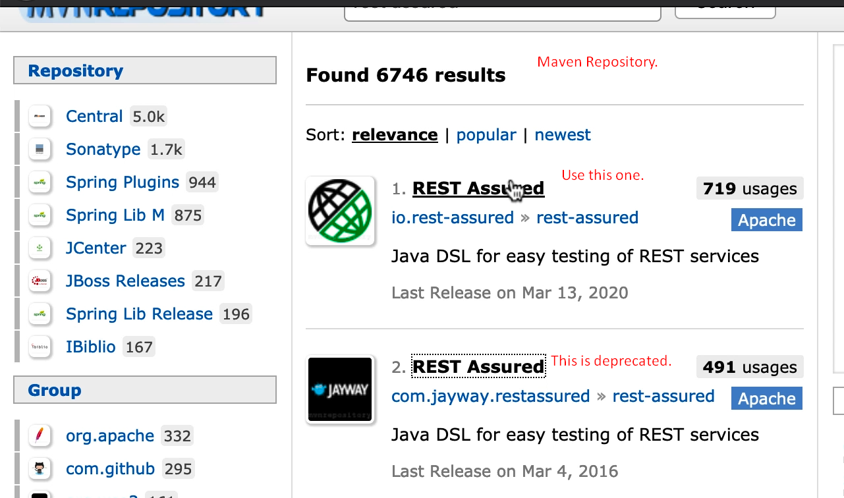
4. **Dependencies**:
   1. Rest Assured: 4.3.0.
   2. JUnit 5
   3. JUnit 5 Engine
   4. JDK 8
5. 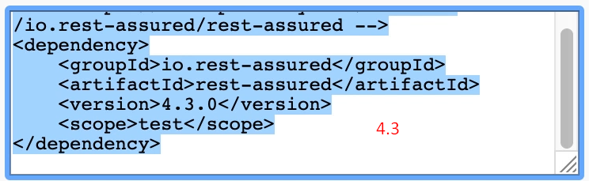
6. 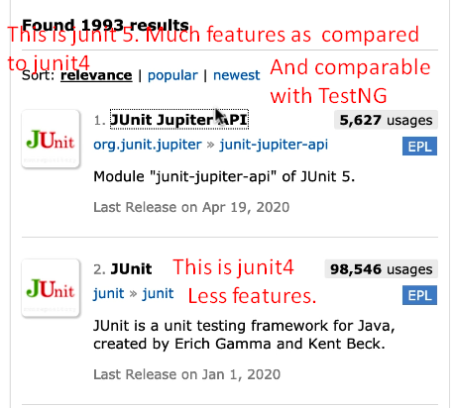
7. 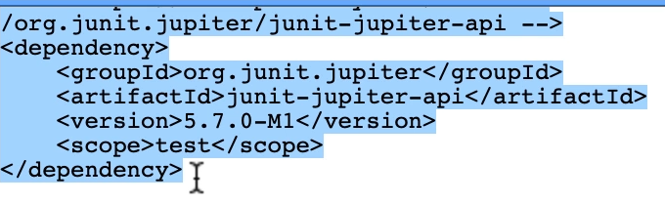
8. 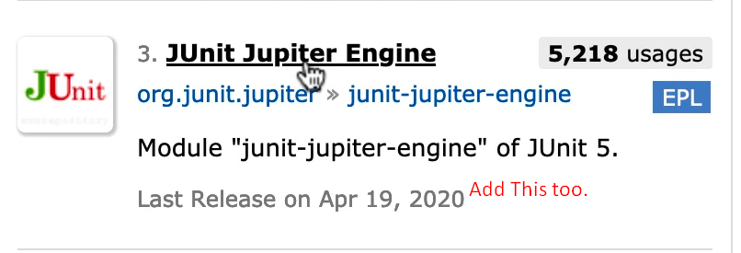
9. 